SRI SAIRAM ENGINEERING COLLEGE
(AN AUTONOMOUS INSTITUTION)
SAI LEO NAGAR, WEST TAMBARAM, CHENNAI-44.
(Accredited by NBA and NAAC “A+”| An ISO 9001:2015 Certified and
MHRD NIRF Ranked Institution)



DEPARTMENT OF COMPUTER SCIENCE AND ENGINEERING

CS8711 –CLOUD COMPUTING LABORATORY
(IV YEAR / VII SEMESTER / BATCH: 2019-2023)

EX.NO | DATE | TITLE | PG. NO | SIGNATURE
1 |  | To create a virtual machine or an instance using open stack software. | 1
2 |  | Install a C compiler in the virtual machine created using virtual box and execute Simple Programs | 7
3 |  | Install Google App Engine. Create a hello world app and other simple web applications using python/java. | 8
4 |  | Use GAE launcher to launch the web applications. | 17
5 |  | Simulate a cloud scenario using CloudSim and run a scheduling algorithm that is not present in CloudSim. | 20
6 |  | Find a procedure to transfer the files from one virtual machine to another virtualmachine. | 42
7 |  | Find a procedure to launch virtual machine using trystack | 44
8 | Install Hadoop single node cluster and run simple applications like word count.
a |  | Hadoop installation – one node hadoop cluster | 49
b |  | Install Hadoop single node cluster and run simple applications like word count. | 56

EX.No 1: To create a virtual machine or an instance using open stack software
AIM:
To create a virtual machine or an instance using open stack software.
PROCEDURE:
1. In the open stack homepage, choose overview tab to look the overview of the system. It displays how many no. of instances, volumes, VCPUs, etc can be created.
2. Click Instances and choose Launch Instances.
3. Give instance name, availability and select the boot source image and volume size to create a virtual machine.
4. After creation, select the created instance and enter username and password in the console and view the file system details.
COMMANDS:
Now click connect.
Change to admin from alt-demo.
Choose Overview
Check the number of instances created.
Create Instance.
Select Project->Instance->LaunchInstance
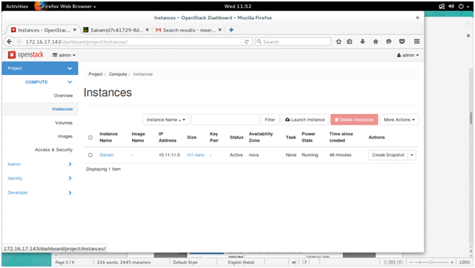

A dialog box opens⇒ Give Instance name=> Set availability zone as nova.=> Set count as 1=>Click next.
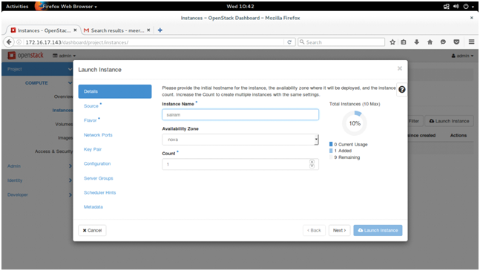

Select boot source as image
Set volume size as 1GB.
Available->cirros-0.3.4-x86_64-uec
select + in cirros-0.3.4-x86_64-uec.
Now cirros-0.3.4-x86_64-uec is moved to allocated

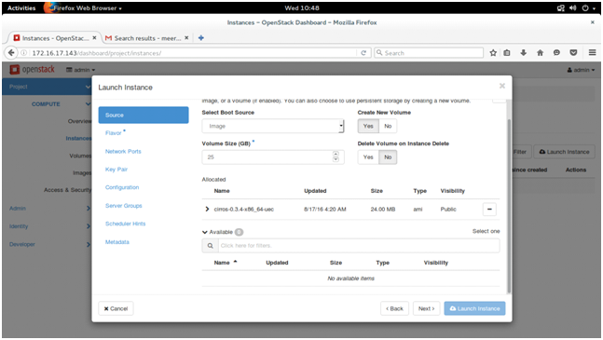
Click next
Select m1.nano in available
Now m1.nano moves to allocated
Click Launch Instance.
A new instance is created
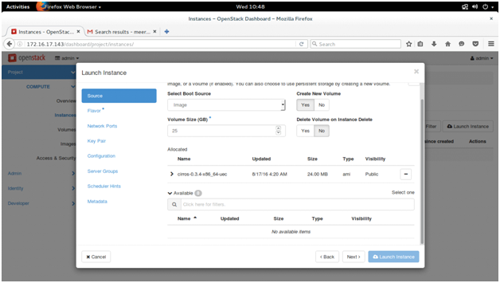
select the instance name ->Sairam
Select console
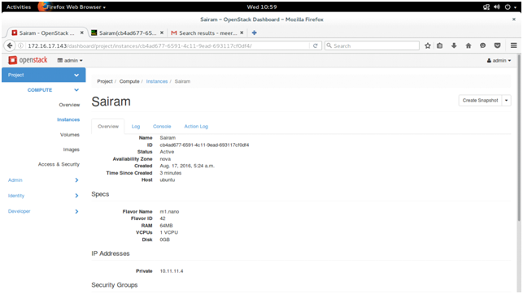

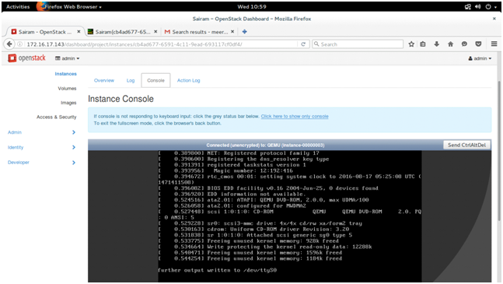
Right Click on “Click here to show only console”->open it in a new tab
Enter
Sairam login:cirros
Password:cubswin:)
$ df -h
The Filesystem details are displayed
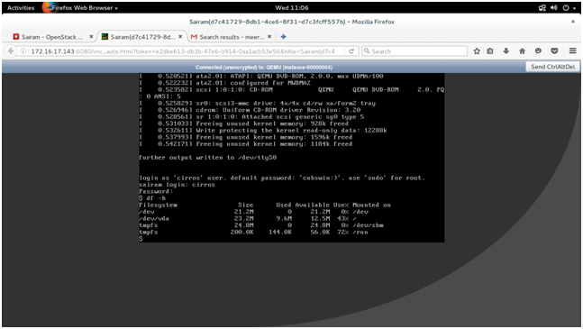

RESULT:
Thus the Virtual machine is created by using open stack.

EXNo 2 : Install a C compiler in the virtual machine created using virtual box and execute simple programs
AIM:
To create and run a sample c program in ubuntu.
PROCEDURE:
1. Open Virtual Box and run the ubuntu virtual machine.
2. Open a terminal in ubuntu virtual machine
3. Create a sample C program
4. Compile the C file with cc command
5. Run the C file with ./a.out command
OUTPUT:
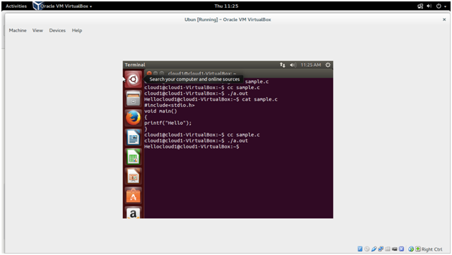
RESULT: Thus the execution of sample C program using ubuntu virtual machine is successfully completed.
EXP NO :3 Install Google App Engine. Create a hello world app and other simple web applications using python/java.
AIM:
To install Google App Engine. Create a hello world app and other simple web applications using python/java.
PROCEDURE:
Tools used :
- JDK 1.6
- Eclipse 3.7 + Google Plugin for Eclipse
- Google App Engine Java SDK 1.6.3.1

Step 1. Install Google Plugin for Eclipse:
In Eclipse 3.7, click “Help” –> “Install New Software…“, copy and paste following URL :
http://dl.google.com/eclipse/plugin/3.7
Select “Google Plugin for Eclipse (required), and Google App Engine SDK for Java.
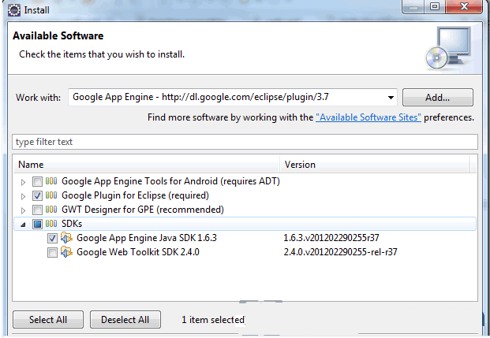

2. Verification
Wait few minutes for the installation progress, when done, Eclipse prompts you to restart, click yes and the Google Plugin for Eclipse is installed.
Figure – A small Google icon is available in the Eclipse toolbar.

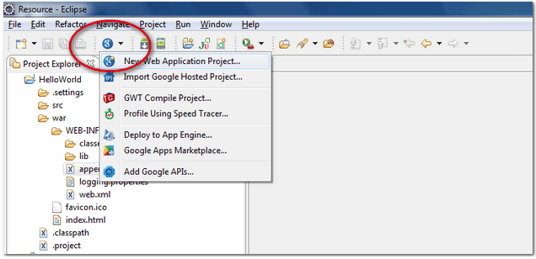

Step 2. Create New Web Application Project
In Eclipse toolbar, click on the Google icon, and select “New Web Application Project…”
Figure – New Web Application Project
Figure – Deselect the “Google Web ToolKit“, and link your GAE Java SDK via the “configure SDK” link.
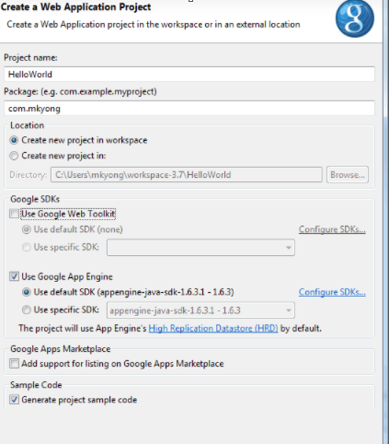
Click finished, Google Plugin for Eclipse will generate a sample project automatically.

Step 3. Hello World
Review the generated project directory.
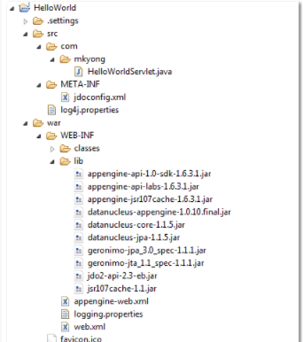
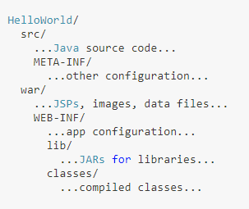
The extra is this file “appengine-web.xml“, Google App Engine need this to run and deploy the application.
File : appengine-web.xml
<?xml version="1.0" encoding="utf-8"?>
<appengine-web-app xmlns="http://appengine.google.com/ns/1.0">
<application></application>
<version>1</version>
<!-- Configure java.util.logging -->
<system-properties>
<property name="java.util.logging.config.file" value="WEB-INF/logging.properties"/>
</system-properties>
</appengine-web-app>
Step 4: Run it local
Right click on the project and run as “Web Application“.
Eclipse console :
//...
INFO: The server is running at http://localhost:8888/
30 Mac 2012 11:13:01 PM com.google.appengine.tools.development.DevAppServerImpl start
INFO: The admin console is running at http://localhost:8888/_ah/admin
Access URL http://localhost:8888/, see output
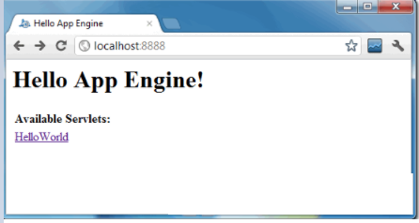
and also the hello world servlet – http://localhost:8888/helloworld
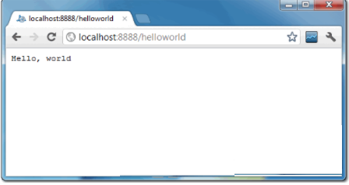

5. Deploy to Google App Engine
Register an account on https://appengine.google.com/, and create an application ID for your web application.
In this demonstration, I created an application ID, named “hello ”, and put it in appengine-web.xml.
File : appengine-web.xml
<?xml version="1.0" encoding="utf-8"?>
<appengine-web-app xmlns="http://appengine.google.com/ns/1.0">
<application>mkyong123</application>
<version>1</version>

<!-- Configure java.util.logging -->
<system-properties>
<property name="java.util.logging.config.file" value="WEB-INF/logging.properties"/>
</system-properties>

</appengine-web-app>
Step 5:To deploy, see following steps:
Figure – Click on GAE deploy button on the toolbar.
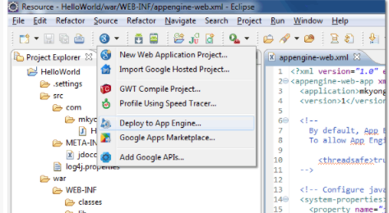
Figure 1.2 – Sign in with your Google account and click on the Deploy button.

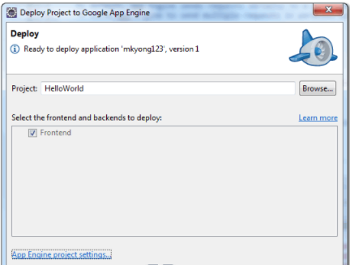
If everything is fine, the hello world web application will be deployed to this URL – http://hello.appspot.com/

RESULT: Thus the installation of Google App Engine ,Create a hello world app and other simple web applications using java is completed.

EXP NO 4: Use GAE launcher to launch the web applications.

AIM:
To create a Google App Engine launcher to launch the web application.

PROCEDURE:
Create a new Cloud Console project or retrieve the project ID of an existing project to use:
GOTO THE PROJECT PAGE
Install and then initialize the Google Cloud SDK:
DOWNLOAD THE SDK
Creating a website to host on Google App Engine

Basic structure for the project
This guide uses the following structure for the project:
- app.yaml: Configure the settings of your App Engine application.
- www/: Directory to store all of your static files, such as HTML, CSS, images, and JavaScript.
  - css/: Directory to store stylesheets.
    - style.css: Basic stylesheet that formats the look and feel of your site.
  - images/: Optional directory to store images.
  - index.html: An HTML file that displays content for your website.
  - js/: Optional directory to store JavaScript files.
  - Other asset directories.

Creating the app.yaml file
The app.yaml file is a configuration file that tells App Engine how to map URLs to your static files. In the following steps, you will add handlers that will load www/index.html when someone visits your website, and all static files will be stored in and called from the www directory.
Create the app.yaml file in your application's root directory:
- Create a directory that has the same name as your project ID. You can find your project ID in the Console.
- In directory that you just created, create a file named app.yaml.
- Edit the app.yaml file and add the following code to the file:
runtime: python27
api_version: 1
threadsafe: true

handlers:
- url: /
static_files: www/index.html
upload: www/index.html

- url: /(.*)
static_files: www/\1
upload: www/(.*)

Creating the index.html file
Create an HTML file that will be served when someone navigates to the root page of your website. Store this file in your www directory.
<html>
<head>
<title>Hello, world!</title>
<link rel="stylesheet" type="text/css" href="/css/style.css">
</head>
<body>
<h1>Hello, world!</h1>
<p>
This is a simple static HTML file that will be served from Google App
Engine.
</p>
</body>
</html>

Deploying your application to App Engine
When you deploy your application files, your website will be uploaded to App Engine. To deploy your app, run the following command from within the root directory of your application where the app.yaml file is located:

gcloud app deploy
Optional flags:
- Include the --project flag to specify an alternate Cloud Console project ID to what you initialized as the default in the gcloud tool. Example: --project [YOUR_PROJECT_ID]
- Include the -v flag to specify a version ID, otherwise one is generated for you. Example: -v [YOUR_VERSION_ID]

Viewing your application
To launch your browser and view the app at https://PROJECT_ID.REGION_ID.r.appspot.com, run the following command:
gcloud app browse

RESULT:
Thus the web application has been launched using Google App Engine.

EXP NO 5:Simulate a cloud scenario using CloudSim and run a scheduling algorithm that is not present in CloudSim.
AIM:
To Simulate a cloud scenario using CloudSim and run a scheduling algorithm that is not present in CloudSim.

PROCEDURE:

To Integrate CloudSim Framework with NetBeans IDE
- Download NetBeans and Install it.
- Download CloudSim and unzip it.
- Once Netbeans IDE is installed, start creating a new Project via File > New Project. Choose “Java” under Categories and “Java Application” under Projects.
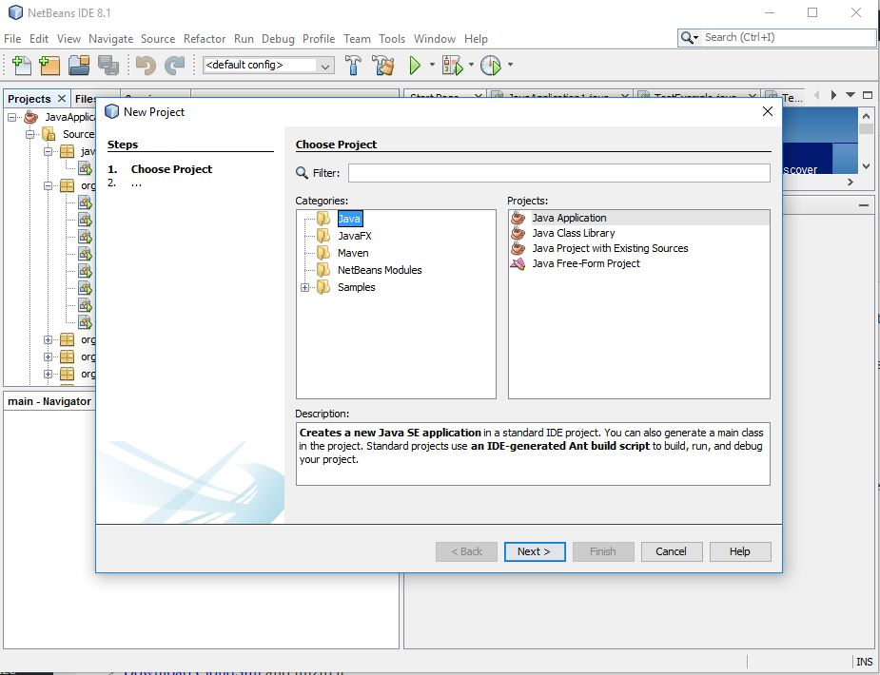

Name your project and click “Finish” button.
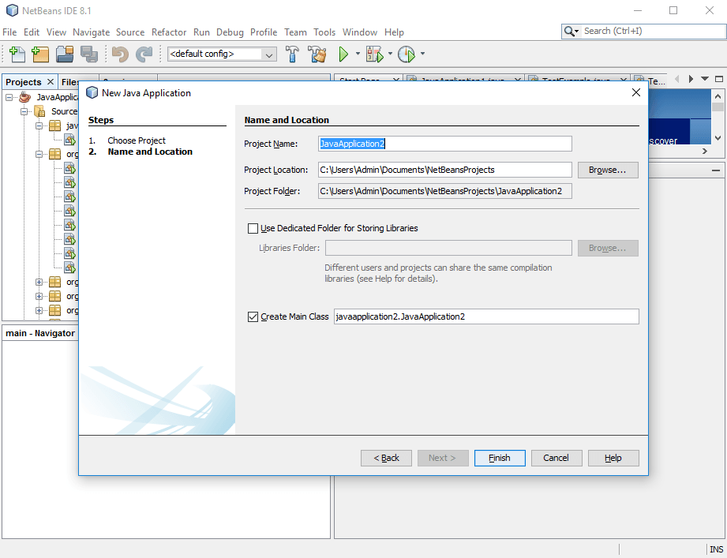
On the left sidebar, right click on the project and select “Properties” as shown below:
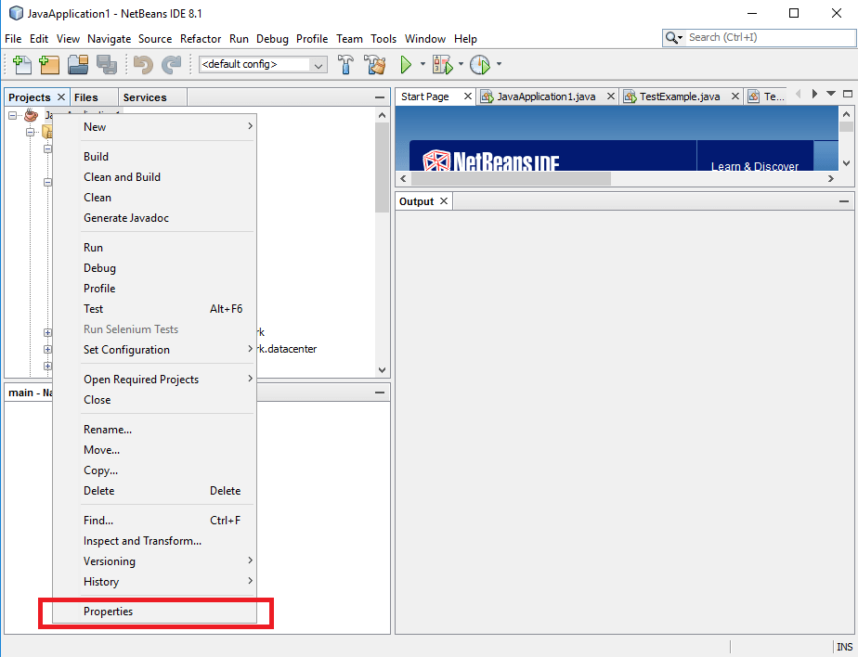
In the properties dialog, select “Libraries” and click on “Add Library” button at the right. In the “Add Library” dialog, select cloudsim jar file (will be located in jars folder) downloaded in step 2. Now you can drag and drop example programs (under examples/org/cloudbus/cloudsim) from the CloudSim directory into your application. That’s it, your CloudSim toolkit it ready to use.
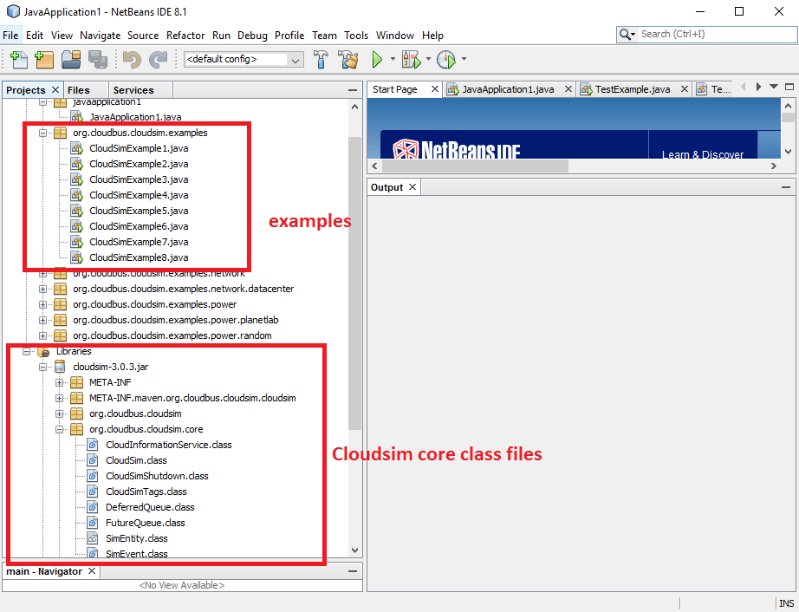
Expand org.cloudbus.cloudsim.examples folder to find all example programs. Select your desired example and start running the simulation. The output will be displayed at the bottom pane as shown below:

package SJF;

SJF_Scheduler.java

import org.cloudbus.cloudsim.*;

import org.cloudbus.cloudsim.core.CloudSim;

import org.cloudbus.cloudsim.provisioners.BwProvisionerSimple;

import org.cloudbus.cloudsim.provisioners.PeProvisionerSimple;

import org.cloudbus.cloudsim.provisioners.RamProvisionerSimple;

import utils.Constants;

import utils.DatacenterCreator;

import utils.GenerateMatrices;

import java.text.DecimalFormat;

import java.util.ArrayList;

import java.util.Calendar;

import java.util.LinkedList;

import java.util.List;

public class SJF_Scheduler {

private static List<Cloudlet> cloudletList;

private static List<Vm> vmList;

private static Datacenter[] datacenter;

private static double[][] commMatrix;

private static double[][] execMatrix;

private static List<Vm> createVM(int userId, int vms) {

//Creates a container to store VMs. This list is passed to the broker later

LinkedList<Vm> list = new LinkedList<Vm>();

//VM Parameters

long size = 10000; //image size (MB)

int ram = 512; //vm memory (MB)

int mips = 250;

long bw = 1000;

int pesNumber = 1; //number of cpus

String vmm = "Xen"; //VMM name

//create VMs

Vm[] vm = new Vm[vms];

for (int i = 0; i < vms; i++) {

vm[i] = new Vm(datacenter[i].getId(), userId, mips, pesNumber, ram, bw, size, vmm, new CloudletSchedulerSpaceShared());

list.add(vm[i]);

}

return list;

}

private static List<Cloudlet> createCloudlet(int userId, int cloudlets, int idShift) {

// Creates a container to store Cloudlets

LinkedList<Cloudlet> list = new LinkedList<Cloudlet>();

//cloudlet parameters

long fileSize = 300;

long outputSize = 300;

int pesNumber = 1;

UtilizationModel utilizationModel = new UtilizationModelFull();

Cloudlet[] cloudlet = new Cloudlet[cloudlets];

for (int i = 0; i < cloudlets; i++) {

int dcId = (int) (Math.random() * Constants.NO_OF_DATA_CENTERS);

long length = (long) (1e3 * (commMatrix[i][dcId] + execMatrix[i][dcId]));

cloudlet[i] = new Cloudlet(idShift + i, length, pesNumber, fileSize, outputSize, utilizationModel, utilizationModel, utilizationModel);

// setting the owner of these Cloudlets

cloudlet[i].setUserId(userId);

cloudlet[i].setVmId(dcId + 2);

list.add(cloudlet[i]);

}

return list;

}

public static void main(String[] args) {

Log.printLine("Starting SJF Scheduler...");

new GenerateMatrices();

execMatrix = GenerateMatrices.getExecMatrix();

commMatrix = GenerateMatrices.getCommMatrix();

try {

int num_user = 1; // number of grid users

Calendar calendar = Calendar.getInstance();

boolean trace_flag = false; // mean trace events

CloudSim.init(num_user, calendar, trace_flag);

// Second step: Create Datacenters

datacenter = new Datacenter[Constants.NO_OF_DATA_CENTERS];

for (int i = 0; i < Constants.NO_OF_DATA_CENTERS; i++) {

datacenter[i] = DatacenterCreator.createDatacenter("Datacenter_" + i);

}

//Third step: Create Broker

SJFDatacenterBroker broker = createBroker("Broker_0");

int brokerId = broker.getId();

//Fourth step: Create VMs and Cloudlets and send them to broker

vmList = createVM(brokerId, Constants.NO_OF_DATA_CENTERS);

cloudletList = createCloudlet(brokerId, Constants.NO_OF_TASKS, 0);

broker.submitVmList(vmList);

broker.submitCloudletList(cloudletList);

// Fifth step: Starts the simulation

CloudSim.startSimulation();

// Final step: Print results when simulation is over

List<Cloudlet> newList = broker.getCloudletReceivedList();

//newList.addAll(globalBroker.getBroker().getCloudletReceivedList());

CloudSim.stopSimulation();

printCloudletList(newList);

Log.printLine(SJF_Scheduler.class.getName() + " finished!");

} catch (Exception e) {

e.printStackTrace();

Log.printLine("The simulation has been terminated due to an unexpected error");

}

}

private static SJFDatacenterBroker createBroker(String name) throws Exception {

return new SJFDatacenterBroker(name);

}

/**

* Prints the Cloudlet objects

*

* @param list list of Cloudlets

*/

private static void printCloudletList(List<Cloudlet> list) {

int size = list.size();

Cloudlet cloudlet;

String indent = " ";

Log.printLine();

Log.printLine("========== OUTPUT ==========");

Log.printLine("Cloudlet ID" + indent + "STATUS" +

indent + "Data center ID" +

indent + "VM ID" +

indent + indent + "Time" +

indent + "Start Time" +

indent + "Finish Time");

DecimalFormat dft = new DecimalFormat("###.##");

dft.setMinimumIntegerDigits(2);

for (int i = 0; i < size; i++) {

cloudlet = list.get(i);

Log.print(indent + dft.format(cloudlet.getCloudletId()) + indent + indent);

if (cloudlet.getCloudletStatus() == Cloudlet.SUCCESS) {

Log.print("SUCCESS");

Log.printLine(indent + indent + dft.format(cloudlet.getResourceId()) +

indent + indent + indent + dft.format(cloudlet.getVmId()) +

indent + indent + dft.format(cloudlet.getActualCPUTime()) +

indent + indent + dft.format(cloudlet.getExecStartTime()) +

indent + indent + indent + dft.format(cloudlet.getFinishTime()));

}

}

double makespan = calcMakespan(list);

Log.printLine("Makespan using SJF: " + makespan);

}

private static double calcMakespan(List<Cloudlet> list) {

double makespan = 0;

double[] dcWorkingTime = new double[Constants.NO_OF_DATA_CENTERS];

for (int i = 0; i < Constants.NO_OF_TASKS; i++) {

int dcId = list.get(i).getVmId() % Constants.NO_OF_DATA_CENTERS;

if (dcWorkingTime[dcId] != 0) --dcWorkingTime[dcId];

dcWorkingTime[dcId] += execMatrix[i][dcId] + commMatrix[i][dcId];

makespan = Math.max(makespan, dcWorkingTime[dcId]);

}

return makespan;

}

}

SJFDatacenterBroker.java
package SJF;
import org.cloudbus.cloudsim.*;
import org.cloudbus.cloudsim.core.CloudSim;
import org.cloudbus.cloudsim.core.CloudSimTags;
import org.cloudbus.cloudsim.core.SimEvent;
import java.util.ArrayList;
import java.util.List;
public class SJFDatacenterBroker extends DatacenterBroker {
SJFDatacenterBroker(String name) throws Exception {
super(name);
}
public void scheduleTaskstoVms() {
int reqTasks = cloudletList.size();
int reqVms = vmList.size();
Vm vm = vmList.get(0);
for (int i = 0; i < reqTasks; i++) {
bindCloudletToVm(i, (i % reqVms));
System.out.println("Task" + cloudletList.get(i).getCloudletId() + " is bound with VM" + vmList.get(i % reqVms).getId());
}
//System.out.println("reqTasks: "+ reqTasks);
ArrayList<Cloudlet> list = new ArrayList<Cloudlet>();
for (Cloudlet cloudlet : getCloudletReceivedList()) {
list.add(cloudlet);
}
//setCloudletReceivedList(null);

Cloudlet[] list2 = list.toArray(new Cloudlet[list.size()]);
//System.out.println("size :"+list.size());
Cloudlet temp = null;
int n = list.size();
for (int i = 0; i < n; i++) {
for (int j = 1; j < (n - i); j++) {
if (list2[j - 1].getCloudletLength() / (vm.getMips() * vm.getNumberOfPes()) > list2[j].getCloudletLength() / (vm.getMips() * vm.getNumberOfPes())) {
//swap the elements!
//swap(list2[j-1], list2[j]);
temp = list2[j - 1];
list2[j - 1] = list2[j];
list2[j] = temp;
}
// printNumbers(list2);
}
}
ArrayList<Cloudlet> list3 = new ArrayList<Cloudlet>();
for (int i = 0; i < list2.length; i++) {
list3.add(list2[i]);
}
//printNumbers(list);
setCloudletReceivedList(list);
//System.out.println("\n\tSJFS Broker Schedules\n");
//System.out.println("\n");
}
public void printNumber(Cloudlet[] list) {
for (int i = 0; i < list.length; i++) {
System.out.print(" " + list[i].getCloudletId());
System.out.println(list[i].getCloudletStatusString());
}
System.out.println();
}
public void printNumbers(ArrayList<Cloudlet> list) {
for (int i = 0; i < list.size(); i++) {
System.out.print(" " + list.get(i).getCloudletId());
}
System.out.println();
}
@Override
protected void processCloudletReturn(SimEvent ev) {
Cloudlet cloudlet = (Cloudlet) ev.getData();
getCloudletReceivedList().add(cloudlet);
Log.printLine(CloudSim.clock() + ": " + getName() + ": Cloudlet " + cloudlet.getCloudletId()
+ " received");
cloudletsSubmitted--;
if (getCloudletList().size() == 0 && cloudletsSubmitted == 0) {
scheduleTaskstoVms();
cloudletExecution(cloudlet);
}
}
protected void cloudletExecution(Cloudlet cloudlet) {
if (getCloudletList().size() == 0 && cloudletsSubmitted == 0) { // all cloudlets executed
Log.printLine(CloudSim.clock() + ": " + getName() + ": All Cloudlets executed. Finishing...");
clearDatacenters();
finishExecution();
} else { // some cloudlets haven't finished yet
if (getCloudletList().size() > 0 && cloudletsSubmitted == 0) {
// all the cloudlets sent finished. It means that some bount
// cloudlet is waiting its VM be created
clearDatacenters();
createVmsInDatacenter(0);
}
}
}
@Override
protected void processResourceCharacteristics(SimEvent ev) {
DatacenterCharacteristics characteristics = (DatacenterCharacteristics) ev.getData();
getDatacenterCharacteristicsList().put(characteristics.getId(), characteristics);
if (getDatacenterCharacteristicsList().size() == getDatacenterIdsList().size()) {
distributeRequestsForNewVmsAcrossDatacenters();
}
}
protected void distributeRequestsForNewVmsAcrossDatacenters() {
int numberOfVmsAllocated = 0;
int i = 0;
final List<Integer> availableDatacenters = getDatacenterIdsList();
for (Vm vm : getVmList()) {
int datacenterId = availableDatacenters.get(i++ % availableDatacenters.size());
String datacenterName = CloudSim.getEntityName(datacenterId);
if (!getVmsToDatacentersMap().containsKey(vm.getId())) {
Log.printLine(CloudSim.clock() + ": " + getName() + ": Trying to Create VM #" + vm.getId() + " in " + datacenterName);
sendNow(datacenterId, CloudSimTags.VM_CREATE_ACK, vm);
numberOfVmsAllocated++; } }
setVmsRequested(numberOfVmsAllocated);
setVmsAcks(0); } }

Result: Thus Cloud scenario using CloudSim and run a scheduling algorithm is successful.

Ex No: 6 Find a procedure to transfer the files from one virtual machine to another virtual machine

AIM:

To transfer the files from one virtual machine to another.

PROCEDURE:
- In Google cloud console create a Ubuntu VMinstance with required configuration and storage
- Then, create a CentOS VM instance with required configuration and storage.
- Now open the 2 VM using SSH Connect
- Enter as root mode in both os by using sudo -i
- In the centos update by using sudo yum update -y
- In the ubuntu os update by using sudo apt update && sudo apt upgrade -y
- Now in ubunto login as auth using gcloud auth login it willprompt for the vertification code which is got by going through the link in terminal.
- The project lists are seen by the command gcloud projects list
- Set the config project as gcloud config set project project_id
- Create a new file named hello by vi hello.txt
- Now after saving the text file ,in the centOS move to ssh directory by cd/etc/ssh/
- Then edit the sshd_config file by setting PermitRootLogin to yes and restart the sshd by studo systemctl restart sshd
- Then in ubuntu OS execute the scp command gcloud compute scp hello.txt – project sample-gcp-01-3ff069eda8a3
  - Centos :/root --zone us-central1-a
- Now in the centos the hello.txt file is created that is being transferred from ubuntu VM

OUTPUT:

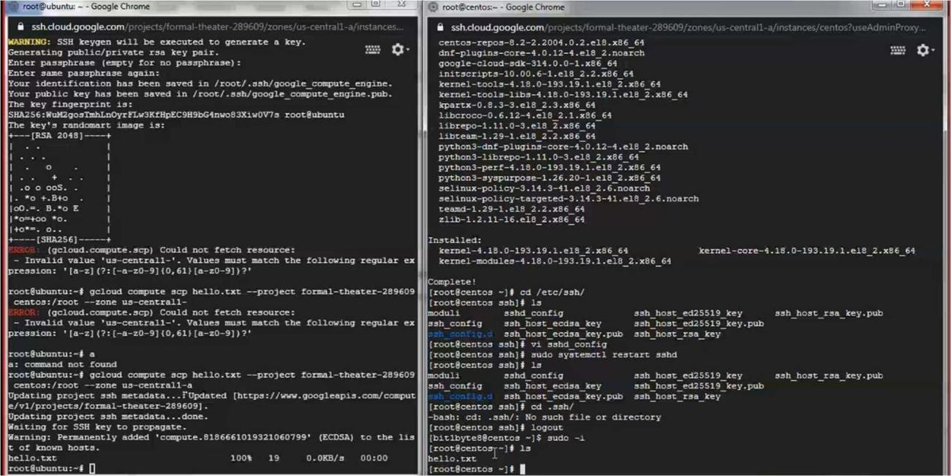

RESULT:
The transfer of files from one virtual machine to another virtual machine is
done.

Ex No: 7 Find a procedure to launch virtual machine using trystack

AIM:
To understand the procedure to launch virtual machine using trystack.

DESCRIPTION:
OpenStack is an open-source software cloud computing platform. OpenStack is primarily used for deploying an infrastructure as a service (IaaS) solution like Amazon Web Service (AWS). In other words, you can make your own AWS by using OpenStack.

PROCEDURE:
- Open trystack page using trystack.org

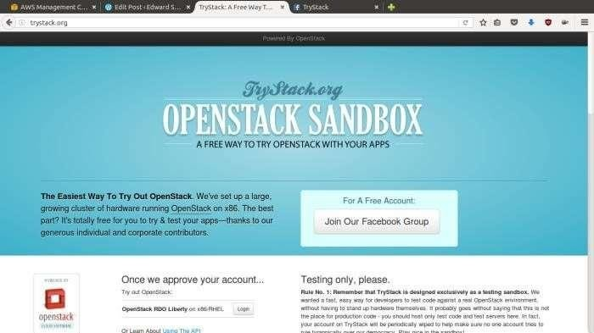

- Login to trystack by creating account.

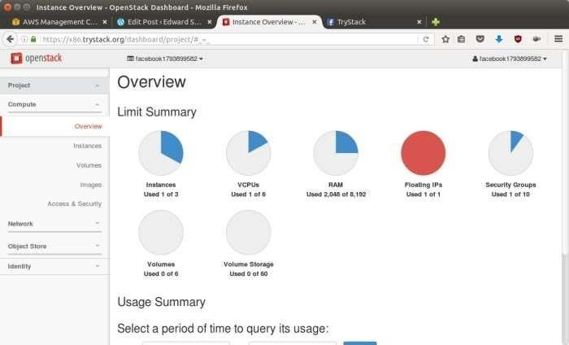

- Create Network

  - Go to Network > Networks and then click Create Network.
  - In Network tab, fill Network Name for example internal and then click Next.
  - In Subnet tab,
  - Fill Network Address with appropriate CIDR, for example 192.168.1.0/24. Use private network CIDR block as the best practice.
  - Select IP Version with appropriate IP version, in this case IPv4.
  - Click Next.
  - In Subnet Details tab, fill DNS Name Servers with 8.8.8.8 (Google DNS) and then click Create.

Create Instance
- Go to Compute > Instances and then click Launch Instance.
- In Details tab,
  - Fill Instance Name, for example Ubuntu 1.
  - Select Flavor, for example m1.medium.
  - Fill Instance Count with 1.
  - Select Instance Boot Source with Boot from Image.
Select Image Name with Ubuntu 14.04 amd64 (243.7 MB) ifyou want install Ubuntu 14.04 in your virtual machine.
- In Access & Security tab,
  - Click [+] button of Key Pair to import key pair. This key pair is a public and private key that we will use to connect to the instance from our machine.
  - In Import Key Pair dialog,
    - Fill Key Pair Name with your machine name (for example Edward- Key).
    - Fill Public Key with your SSH public key (usually is in
~/.ssh/id_rsa.pub). See description in Import Key Pair dialog box for more information. If you are using Windows, you can use Puttygen to generate key pair.
    - Click Import key pair.
  - In Security Groups, mark/check default.
- In Networking tab,
  - In Selected Networks, select network that have been created in Step 1, for example internal.
- Click Launch.
- If you want to create multiple instances, you can repeat step 1-5. I created one more instance with instance name Ubuntu 2.

Create Router
  - Go to Network > Routers and then click Create Router.
  - Fill Router Name for example router1 and then click Create router.
  - Click on your router name link, for example router1, Router Details page.
  - Click Set Gateway button in upper right:
    - Select External networks with external.
    - Then OK.
  - Click Add Interface button.
    - Select Subnet with the network that you have been created in Step 1.
    - Click Add interface.
  - Go to Network > Network Topology. You will see the network topology. In the example, there are two network, i.e. external and internal, those are bridged by a router. There are instances those are joined to internal network

Configure Floating IP Address

Floating IP address is public IP address. It makes your instance is accessible from the internet. When you launch your instance, the instance will have a private network IP, but no public IP. In OpenStack, the public IPs is collected in a pool and managed by admin.

  - Go to Compute > Instance.
  - In one of your instances, click More > Associate Floating IP.
  - In IP Address, click Plus [+].
  - Select Pool to external and then click Allocate IP.
  - Click Associate.
  - Now you will get a public IP, e.g. 8.21.28.120, for your instance.

Configure Access & Security
OpenStack has a feature like a firewall. It can whitelist/blacklist your in/out connection. It is called Security Group.

  - Go to Compute > Access & Security and then open Security Groups tab.
  - In default row, click Manage Rules.
  - Click Add Rule, choose ALL ICMP rule to enable ping into your instance, and then click Add.
  - Click Add Rule, choose HTTP rule to open HTTP port (port 80), and then click Add.
  - Click Add Rule, choose SSH rule to open SSH port (port 22), and then click Add.
  - You can open other ports by creating new rules.

SSH to Your Instance

Now, you can SSH your instances to the floating IP address that you got in the step
4. If you are using Ubuntu image, the SSH user will be ubuntu.
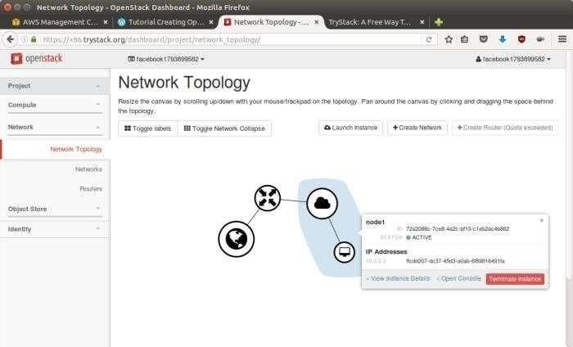

RESULT:

Thus, the procedure to launch virtual machine in trystack is studied.

EXP NO 8: Install Hadoop single node cluster and run simple applications like word count.
a. HADOOP INSTALLATION – ONE NODE HADOOP CLUSTER
AIM:
To install a hadoop environment in ubuntu.
PROCEDURE:
1. Unzip the files jdk and hadoop.
2. Set the path of jdk and hadoop in /etc/profile file
3. Check the updation of file by source command.
4. Update 5 files as soon in the below command.
5. Format the path.
6. Start the dfs and check the no. of nodes running.
7. Start the yarn and check the no. of nodes running.
8. Open the browser and check whether the hadoop is installed correctly.
9. Add a file and check whether we can view the file.
10. After completing the process stop dfs and yarn properly.

COMMANDS:
cloud@ubuntu:~$ ls
Desktop Downloads exp2.odt oddeven Public Videos
Documents exp1.odt Music Pictures Templates VirtualBox VMs
cloud@ubuntu:~$ cd Downloads
cloud@ubuntu:~/Downloads$ tar zxvf jdk-8u60-linux-x64.gz
cloud@ubuntu:~/Downloads$ cd jdk1.8.0_60/
cloud@ubuntu:~/Downloads/jdk1.8.0_60$ pwd
/home/cloud/Downloads/jdk1.8.0_60 - COPY THE PATH
cloud@ubuntu:~/Downloads/jdk1.8.0_60$ sudo nano /etc/profile
A file opens and after the below two lines add
# /etc/profile: system-wide .profile file for the Bourne shell (sh(1))
# and Bourne compatible shells (bash(1), ksh(1), ash(1), ...).
Type the lines as follows
JAVA_HOME=/home/cloud/Downloads/jdk1.8.0_60
PATH=$PATH:$JAVA_HOME/bin
export PATH JAVA_HOME
cloud@ubuntu:~/Downloads/jdk1.8.0_60$ source /etc/profilecloud@ubuntu:~/Downloads/jdk1.8.0_60$ java -version
java version "1.8.0_60"
Java(TM) SE Runtime Environment (build 1.8.0_60-b27)
Java HotSpot(TM) 64-Bit Server VM (build 25.60-b23, mixed mode)
cloud@ubuntu:~/Downloads/jdk1.8.0_60$ sudo apt-get install openssh-server
[sudo] password for cloud:
cloud@ubuntu:~/Downloads/jdk1.8.0_60$ ssh-keygen
Press enter key, no need to type enter key.
cloud@ubuntu:~/Downloads/jdk1.8.0_60$ ssh-copy-id -i localhost
cloud@localhost's password:
cloud@ubuntu:~/Downloads/jdk1.8.0_60$ cd ..
cloud@ubuntu:~/Downloads$ tar zxvf hadoop-2.7.0.tar.gz
cloud@ubuntu:~/Downloads$ cd hadoop-2.7.0/
cloud@ubuntu:~/Downloads/hadoop-2.7.0$ pwd
/home/cloud/Downloads/hadoop-2.7.0 - COPY THE PATH
cloud@ubuntu:~/Downloads/ hadoop-2.7.0$ sudo nano /etc/profile
A file opens and after the below two lines add
# /etc/profile: system-wide .profile file for the Bourne shell (sh(1))
# and Bourne compatible shells (bash(1), ksh(1), ash(1), ...).
Type the lines as follows
JAVA_HOME=/home/cloud/Downloads/jdk1.8.0_60
HADOOP_PREFIX=/home/cloud/Downloads/hadoop-2.7.0
PATH=$PATH:$JAVA_HOME/bin
PATH=$PATH:$HADOOP_PREFIX/bin
export PATH JAVA_HOME HADOOP_PREFIX
cloud@ubuntu:~/Downloads/hadoop-2.7.0$ source /etc/profile
cloud@ubuntu:~/Downloads/hadoop-2.7.0$ bin/hadoop version
Hadoop 2.7.0
cloud@ubuntu:~/Downloads/hadoop-2.7.0$ cd etc
cloud@ubuntu:~/Downloads/hadoop-2.7.0/etc$ cd hadoop
cloud@ubuntu:~/Downloads/hadoop-2.7.0/etc/hadoop$ nano hadoop-env.sh
Goto the end of the file and enter the line
export JAVA_HOME=/home/cloud/Downloads/jdk1.8.0_60
export HADOOP_PREFIX=/home/cloud/Downloads/hadoop-2.7.0
cloud@ubuntu:~/Downloads/hadoop-2.7.0/etc/hadoop$ nano core-site.xml
Inside the configuration tag insert the following lines
<configuration>
<property>
<name>fs.defaultFS</name>
<value>hdfs://localhost:9000</value>
</property>
</configuration>
cloud@ubuntu:~/Downloads/hadoop-2.7.0/etc/hadoop$ nano hdfs-site.xml
Inside the configuration tag insert the following lines
<configuration>
<property>
<name>dfs.replication</name>
<value>1</value>
</property>
</configuration>
cloud@ubuntu:~/Downloads/hadoop-2.7.0/etc/hadoop$ cp mapred-site.xml.template mapred-site.xml
cloud@ubuntu:~/Downloads/hadoop-2.7.0/etc/hadoop$ nano mapred-site.xml
Inside the configuration tag insert the following lines
<configuration>
<property>
<name>mapreduce.framework.name</name>
<value>yarn</value>
</property>
</configuration>
cloud@ubuntu:~/Downloads/hadoop-2.7.0/etc/hadoop$ nano yarn-site.xml
<configuration>
<!-- Site specific YARN configuration properties -->
<property>
<name>yarn.nodemanager.aux-services</name>
<value>mapreduce_shuffle</value>
</property>
</configuration>
cloud@ubuntu:~/Downloads/hadoop-2.7.0/etc/hadoop$ cd ..
cloud@ubuntu:~/Downloads/hadoop-2.7.0/etc$ cd ..
cloud@ubuntu:~/Downloads/hadoop-2.7.0$ bin/hadoop namenode -format
cloud@ubuntu:~/Downloads/hadoop-2.7.0$ sbin/start-dfs.sh
cloud@ubuntu:~/Downloads/hadoop-2.7.0$ jps
5632 DataNode
5428 NameNode
5979 Jps
5851 SecondaryNameNode
cloud@ubuntu:~/Downloads/hadoop-2.7.0$ sbin/start-yarn.sh
cloud@ubuntu:~/Downloads/hadoop-2.7.0$ jps
5632 DataNode
6209 NodeManager
6050 ResourceManager
5428 NameNode
6522 Jps
5851 SecondaryNameNode
Open a browser and type as: http:\\localhost:50070.
Choose DataNode.You can see a single node created in it
You can see the folder created inside the utilities tab.
cloud@ubuntu:~/Downloads/hadoop-2.7.0$ bin/hdfs dfs -mkdir /user1
Open a new terminal
cloud@ubuntu:~/Downloads/hadoop-2.7.0$ cd ..
cloud@ubuntu:~/Downloads$ tar zxvf mrsampledata.tar.gz
file2.txt
file5.txt
file1.txt
file4.txt
file3.txt
cloud@ubuntu:~/Downloads/hadoop-2.7.0$ bin/hdfs dfs -put ../file1.txt /user1
Inside the browser. Click the folder name user1 and you can see the file1.txt file inside the user1 folder
After completing all the process, stop the dfs and yarn as follows:
cloud@ubuntu:~/Downloads/hadoop-2.7.0$ sbin/stop- yarn.sh
cloud@ubuntu:~/Downloads/hadoop-2.7.0$ sbin/stop- dfs.sh
RESULT:Thus hadoop is installed in the physical machine and executed successfully.
8 b. Install Hadoop single node cluster and run simple applications like word count.
AIM:
Install Hadoop single node cluster and run simple applications like word count.
PROCEDURE:
1. Format the path.
2. Start the dfs and check the no. of nodes running.
3. Start the yarn and check the no. of nodes running.
4. Open the browser and check whether the hadoop is installed correctly.
5. Add a file and check whether we can view the file.
6. Implement the grep command for the file added and see the result.
7. Implement the wordcount command for the file added and see the result.
8. After completing the process stop dfs and yarn properly.

COMMANDS:
cloud@ubuntu:~/Downloads/hadoop-2.7.0$ bin/hadoop namenode -format
cloud@ubuntu:~/Downloads/hadoop-2.7.0$ sbin/start-dfs.sh
cloud@ubuntu:~/Downloads/hadoop-2.7.0$ jps
5632 DataNode
5428 NameNode
5979 Jps
5851 SecondaryNameNode
cloud@ubuntu:~/Downloads/hadoop-2.7.0$ sbin/start-yarn.sh
cloud@ubuntu:~/Downloads/hadoop-2.7.0$ jps
5632 DataNode
6209 NodeManager
6050 ResourceManager
5428 NameNode
6522 Jps
5851 SecondaryNameNode
cloud@ubuntu:~/Downloads/hadoop-2.7.0$ sbin/stop-dfs.sh
cloud@ubuntu:~/Downloads/hadoop-2.7.0$ sbin/stop-yarn.sh
Open a browser and type as: http:\\localhost:50070.
Choose DataNode.you can see a single node created in it. You can see the folder created inside the utilities tab.
cloud@ubuntu:~/Downloads/hadoop-2.7.0$ bin/hdfs dfs -mkdir /user1
Open a new terminal
cloud@ubuntu:~/Downloads/hadoop-2.7.0$ cd ..
cloud@ubuntu:~/Downloads$ tar zxvf mrsampledata.tar.gz
file2.txt
file5.txt
file1.txt
file4.txt
file3.txt
cloud@ubuntu:~/Downloads/hadoop-2.7.0$ bin/hdfs dfs -put ../file1.txt /user1
Inside the browser. Click the folder name user1 and you can see the file1.txt file inside the user1 folder.
cloud@ubuntu:~/Downloads/hadoop-2.7.0$ bin/hadoop jar share/hadoop/mapreduce/hadoop-mapreduce-examples-2.7.0.jar grep /user1/* /output '(CSE)'
cloud@ubuntu:~/Downloads/hadoop-2.7.0$ bin/hadoop jar share/hadoop/mapreduce/hadoop-mapreduce-examples-2.7.0.jar wordcount /user1/file1.txt /output1
cloud@ubuntu:~/Downloads/hadoop-2.7.0$ bin/hdfs dfs -cat /output/*
9894 CSE
cloud@ubuntu:~/Downloads/hadoop-2.7.0$ bin/hdfs dfs -cat /output1/*
B.ARCH 9864
B.TECH(BIO) 9964
B.TECH(IT) 10000
BE(AME) 9853
BE(CIVIL) 10043
BE(CSE) 9894
BE(ECE) 10048
BE(EEE) 9937
BE(ICE) 9872
BE(MECH) 9873
You can also see the output by
1) output
Inside Browser Directory
output --> part-r-00000 --> Click Download
2) output1
Inside Browser Directory
output --> part-r-00000 --> Click Download

RESULT:
Thus the word count program using map and reduce tasks is executed successfully.

